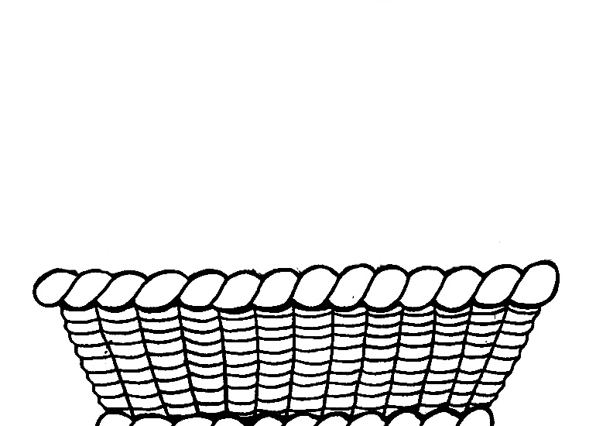

|  |
| --- |
| http://www.catedu.es/arasaac/classes/img/thumbnail.php?i=cdb4ae007dd4b3b4ec6e9c2eb5d2f3b0e5b73fdd5216cece9d9f0709ca904497c988f78aa80b44e53fd65acddada755d163550http://www.catedu.es/arasaac/classes/img/thumbnail.php?i=cdb4ae007dd4b3b4ec6e9c2eb5d2f3b0e5b73fdd5216cece9d9f0709ca904497c988f78aa80b44e53fd65acddbd67b5d163550http://www.catedu.es/arasaac/classes/img/thumbnail.php?i=cdb4ae007dd4b3b4ec6e9c2eb5d2f3b0e5b73fdd5216cece9d9f0709ca904497c988f78aa80b44e53fd65acddadd715d163550http://www.catedu.es/arasaac/classes/img/thumbnail.php?i=cdb4ae007dd4b3b4ec6e9c2eb5d2f3b0e5b73fdd5216cece9d9f0709ca904497c988f78aa80b44e53fd65ac7ded97a5d163550http://www.catedu.es/arasaac/classes/img/thumbnail.php?i=cdb4ae007dd4b3b4ec6e9c2eb5d2f3b0e5b73fdd5216cece9d9f0709ca904497c988f78aa80b44e53fd65acdd5d9735d163550http://www.catedu.es/arasaac/classes/img/thumbnail.php?i=cdb4ae007dd4b3b4ec6e9c2eb5d2f3b0e5b73fdd5216cece9d9f0709ca904497c988f78aa80b44e53fd65acad9de735d163550 |